Misspecification Bias

Anscombe's Quartet

 | x1 | y1 |  | x2 | y2 |  | x3 | y3 |  | x4 | y4
1 | 10 | 8.04 |  | 10 | 9.14 |  | 10 | 7.46 |  | 8 | 6.58
2 | 8 | 6.95 |  | 8 | 8.14 |  | 8 | 6.77 |  | 8 | 5.76
3 | 13 | 7.58 |  | 13 | 8.74 |  | 13 | 12.74 |  | 8 | 7.71
4 | 9 | 8.81 |  | 9 | 8.77 |  | 9 | 7.11 |  | 8 | 8.84
5 | 11 | 8.33 |  | 11 | 9.26 |  | 11 | 7.81 |  | 8 | 8.47
6 | 14 | 9.96 |  | 14 | 8.1 |  | 14 | 8.84 |  | 8 | 7.04
7 | 6 | 7.24 |  | 6 | 6.13 |  | 6 | 6.08 |  | 8 | 5.25
8 | 4 | 4.26 |  | 4 | 3.1 |  | 4 | 5.39 |  | 19 | 12.5
9 | 12 | 10.84 |  | 12 | 9.13 |  | 12 | 8.15 |  | 8 | 5.56
10 | 7 | 4.82 |  | 7 | 7.26 |  | 7 | 6.42 |  | 8 | 7.91
11 | 5 | 5.68 |  | 5 | 4.74 |  | 5 | 5.73 |  | 8 | 6.89
Mean | 9 | 7.5 |  | 9 | 7.5 |  | 9 | 7.5 |  | 9 | 7.5
Variance | 11 | 4.12 |  | 11 | 4.12 |  | 11 | 4.12 |  | 11 | 4.12
Correlation | 0.816 |  |  | 0.816 |  |  | 0.816 |  |  | 0.816
Regression | y = 3 + 0.5x |  |  | y = 3 + 0.5x |  |  | y = 3 + 0.5x |  |  | y = 3 + 0.5x

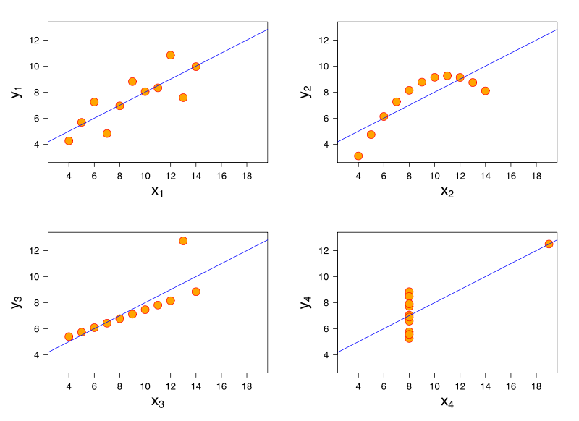

(Borrowed from wikipedia: Anscombe's Quartet )

